**Practice of making traffic lights using wokwi**

*Agatha Herma Putra*

*Fakultas Vokasi, Universitas Brawijaya*

*Email: agathaputra24@student.ub.ac.id*

**Abstract**

This study aims to design a simple traffic light system using ESP32 and LED based on simulation in Wokwi. This system was developed by utilizing ESP32 as a microcontroller that controls the lights based on programming code. In its implementation, ESP32 provides signals to the LED according to the programmed sequence to imitate the function of traffic lights. The test results show that the system can work well in controlling the change of lights according to the established rules. This study proves that ESP32 can be used as an efficient solution in the simulation and implementation of a simple traffic light system.

*Keywords : ESP32, LED, Wokwi, Traffic Light, Simulation, Microcontroller, Programming, Automation.*

**1 Introduction**

**1.1 Background**

In use such as traffic lights, it will certainly require a lot of power or energy to turn them on. With this Wokwi simulation and ESP32 which uses small power, a traffic system can be created using small power..

**1.2 Purpose of the experiment**

The purpose of this simulation is to find out how traffic works using the simulation from Wokwi and also to find out how traffic lights can turn on red for a few seconds or yellow and green lights, by utilizing the Wokwi platform and also VS code.

**2.1 Methodology**

The user wants a methodology for building a simple traffic light system using ESP32 and LEDs. I think I need to break it down clearly into steps. First, I’ll define the simulation environment and hardware needed (like the ESP32 and LEDs). Then, I'll outline the programming steps involved. Lastly, I'll explain the testing procedure. Since the conversation is in Indonesian, I’ll write this methodology step-by-step in Indonesian with enough detail to cover each part. I'll organize it into bullet points or numbered steps.

**2.2 Tools & Materials**

To successfully complete the account creation process on Wokwi and GitHub, several tools and materials are required. These include:

1. Hardware Requirements
   * A computer or laptop with an internet connection
   * A web browser (Google Chrome, Mozilla Firefox, Microsoft Edge, or any other compatible browser)
2. Software & Online Platforms
   * Wokwi (accessible at <https://wokwi.com>)
   * Microsoft Visual Studio Code
3. Additional Tools (Optional)
   * A text editor (such as Visual Studio Code or Notepad++) for working with GitHub repositories
   * A Git client (such as Git Bash or GitHub Desktop) for version control testing

These tools and materials ensure a smooth and efficient process for creating accounts and exploring the basic functionalities of both platforms.

**2.3 Implemention Steps**

Implementation for experiment making traffic lights using esp 32 and **Wokwi** simulator:

**1. Accessing the Platforms**

* Open a web browser on a computer or laptop.
* Navigate to the official websites:
  + **Wokwi**: <https://wokwi.com>

**2. Sign Uo Wokwi Account**

* Click on the **"Sign Up"** button.
* Enter the required details, including:
  + A valid email address
  + A username
* Click **"Sign Up"** to proceed.
* Log in to the Wokwi account and explore the available features, such as microcontroller simulations.

**3. Create Starter Template using esp32**

* Open Wokwi on the initial display or homepage.
* On the main page select ESP32 controller
* Scroll down until you find the starter template.
* Select on ESP 32 template.

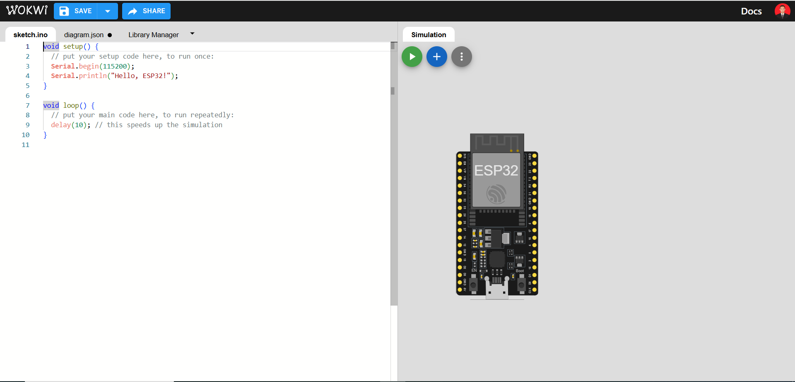

ESP 32 Starter template main view

**4. Added electronic components to the ESP 32**

* In the worksheet click on the plus button.
* Select 3 LED lights as traffic lights with three different colors, namely red, yellow, green.
* And connect each LED to the ESP32 according to the following picture

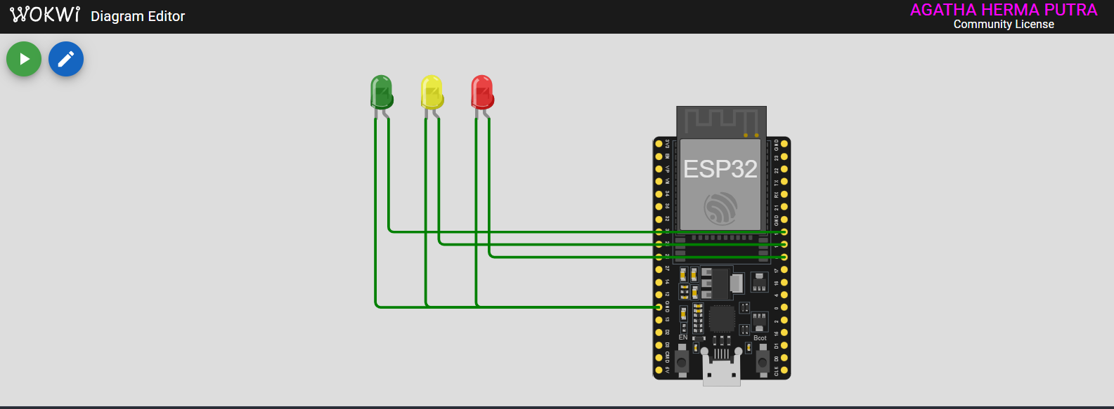

LED Light Display and Cable Placement

**5. Enter the coding to run the light command**

* Copy the following code and paste it into wokwi simulator or VS Code to run the lights..

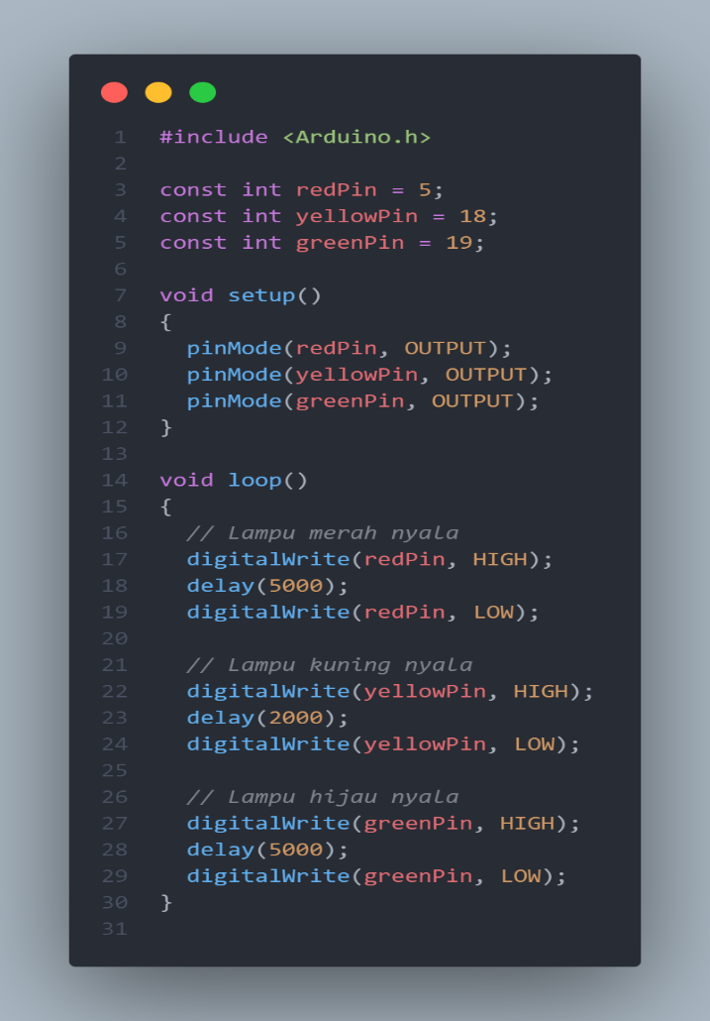

Coding to execute commands

By following these steps, users can successfully create and utilize their Wokwi account for simulation and development purposes in terms of simulation for traffic lights.

**3. Results and Discussion**

**3.1 Experimental Results**

This experiment involved creating a Traffic Light Scheme in Wokwi and VSCode and testing the basic functionality of the account. The following results were obtained:

* **Schema Development**

The traffic light schema was successfully created in Wokwi and VSCode.

* **Functionality Testing**

Basic functionality of the account was tested and verified.

* **Code Implementation**

The traffic light program was executed as designed.

* **Observation Results**

The system functioned as expected, following traffic light rules.

* **Evaluation**

No major issues were found, but further optimization is needed for code efficiency.

**3.2 Performance and User Experience Documentation**

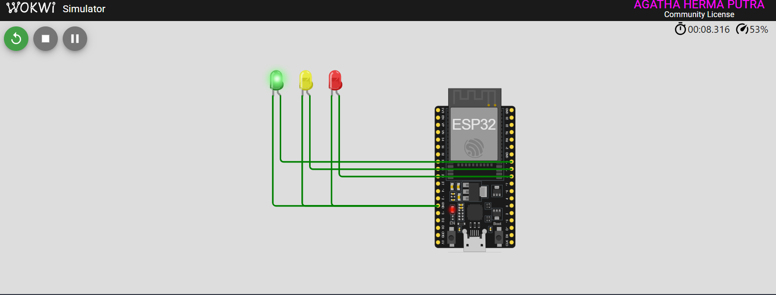

The light is green

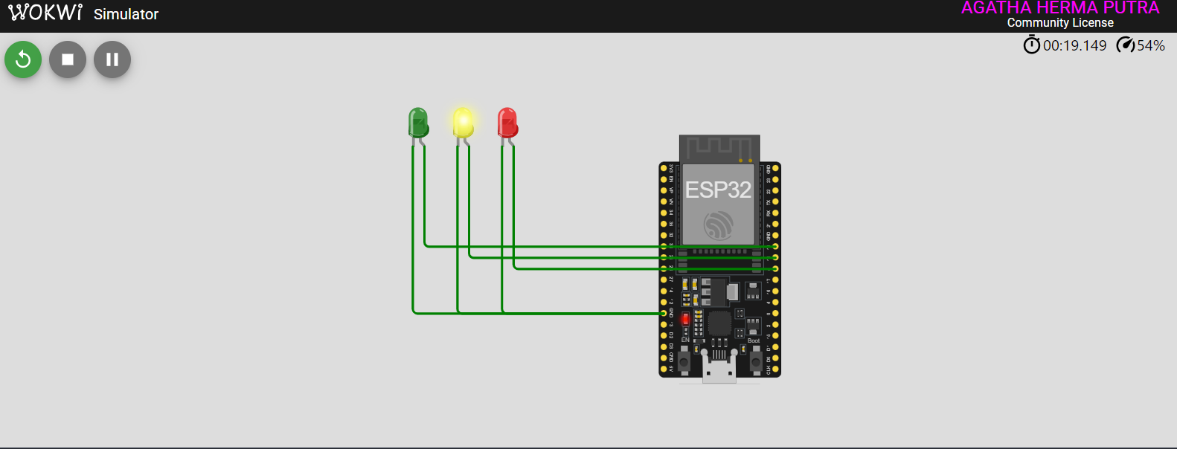

The light is Yellow

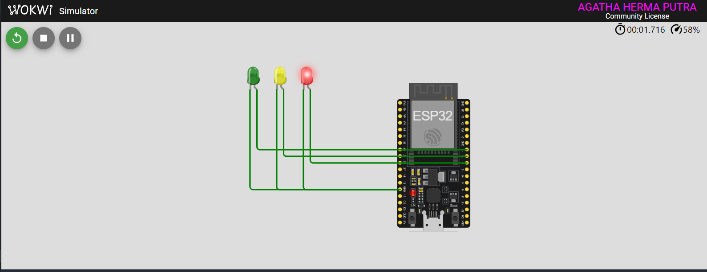

The light is Red

**4. Appendix**

**A. Links to Official Websites**

The following links were used during the experiment for account registration and platform access:

* **Wokwi**: <https://wokwi.com>
* **GitHub**: <https://github.com>

**B. Required System Specifications**

To ensure smooth execution of the experiment, the following system requirements were met:

* **Device**: Laptop with at least 4GB RAM
* **Operating System**: Windows 10 / macOS / Linux
* **Browser**: Google Chrome (Version 100+)
* **Internet Connection**: Stable with a minimum speed of 5 Mbps